Homepage

Header/Hero Section
- Slider kanan – kiri (Solution yang akan dihighlight image/video)
  - Enterprise Solution Provider Concept (adopt dari content yg di Kalender) - Video
  - SATU AI – Video
  - MeshDefend – Video
- Discover Company (List of section di dalam homepage)

2nd Section – STT Value Added/Proposition
- Judul : Our Portfolio
- Content :
  - 425+ Projects
  - 200+ Clients
  - 100% Satisfaction
  - 26 Awards

3rd Section – Our Solutions
  - 5 Pilar Solutions
  - Section Solution dibuat tiap scroll berganti solution (Infrastructure s/d AI Platform) + description singkat + logo2 principle (reference scale.com)

4th Section – Our Industry
  - 7 Industries (FSI & E-Commerce, Manufacture & FMCG, Healthcare, Law Enforcement, Energy, Telecommunication (ICT), Cross Industry (Media, Education, Real Estate)).
  - Dibuat automatically rotate & kursor ke kategori sync ke keterangan nya (reference scale.com)

5th Section – News
  - Updated content article/news
  - Layout kiri (description singkat slider)
  - Layout kanan (list updated content)

6th Section – Why Us
  - Content
    - Tailored solutions with 10+ years experienced
    - Broad Range of Solutions & Services
    - Enterprise Solutions Mastery
    - Customer Success Satisfaction
  - Design/Layout
    - Opsi 1 : dibuat slider seperti di PPT STT sebelumnya
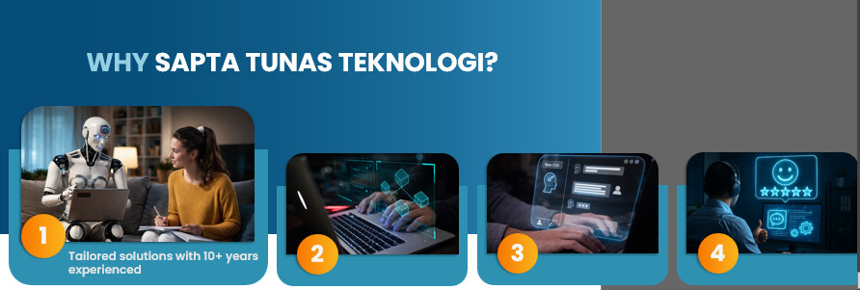

    - Opsi 2 : dibuat seperti berputar, automatically berputar (slider dari lingkaran/bentukan besar semakin ke kiri mengecil, poin yang sedang dihighlight, gambar itu yang besar kemudian poin lain kecil). Contoh :
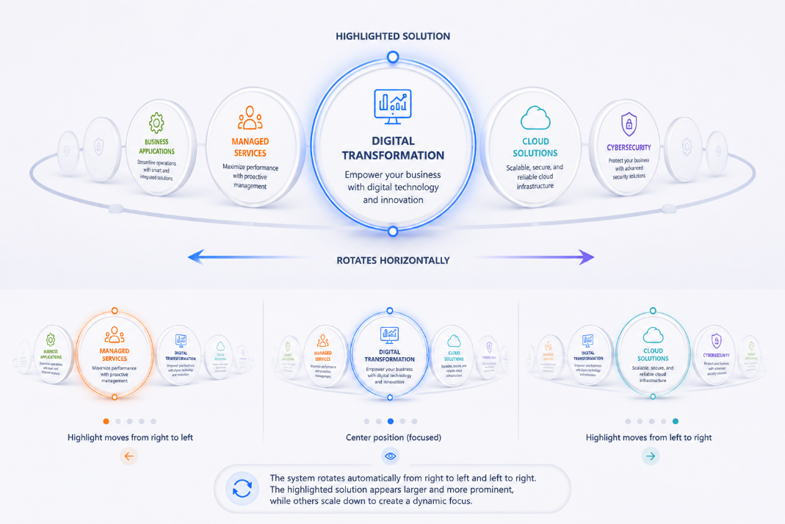

7th Section – Customer Testimonial & CTA (Call to Action)
- What They Say About Us? - Kanan

- Content :
  - Based on target list
- Design
  - Nama company
  - Logo
  - Testimonial words
  - Name + Job Title

- CTA (Request Proposal) - Kiri
- Content :
  - Request Proposal (description singkat)
  - Form (Full Name, Email, Mobile Phone, Company/Organization, Job Role, Industries, Locations, Select Solutions, Message, Submit button)
- Design
  - Kolom form

9th CTA Button
- Kanan
  - Virtual Assitant (Reference dell/en-us)
  - Akan dibuat pop up kecil di sebelah kanan

- Kiri
  - Need Help button (WA Chat, LinkedIn, Youtube, IG, FB)

10th Footer
- Logo
- Solutions List (Modern Infrastructure, Data, AI, CyberSecurity, AI Apps Platform)
- Company
- Help & Support
- Copyright © 2026 Sapta Tunas Teknologi | All Rights Reserved | Privacy Policy | Compliance Policy – Entreprise Solution Provider + Social Media STT

